An emergency and urgent care physician describes and answers questions regarding his first Emergency Department experiences using Centurion’s new IRIG-8™ Wound Irrigation System:
In both the emergency department and urgent care settings, large lacerations are a common part of our practice. Typical wound irrigation technique uses a 20 or 30 cc syringe and a splash guard. We use Centurion's laceration kits, and place saline into the blue basin for wound irrigation. I was very excited about the IRIG-8 device and looked forward to using it.
I recently took care of an 86-year-old woman with a head injury. Living on a farm, she had been in the backyard feeding her animals, lost her balance, and struck her forehead on a metal pail and then the ground. She had a 15 cm scalp laceration which was grossly contaminated with dirt and debris. I am working in a single coverage ED, knowing that this is going to take a long time to repair. (Patient consent to photograph was obtained.)
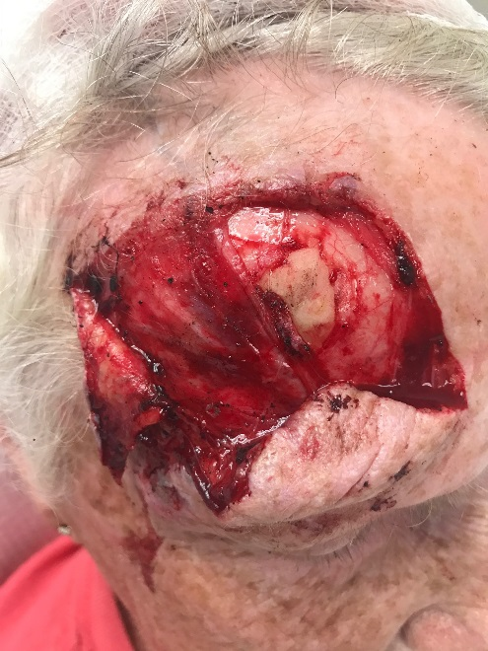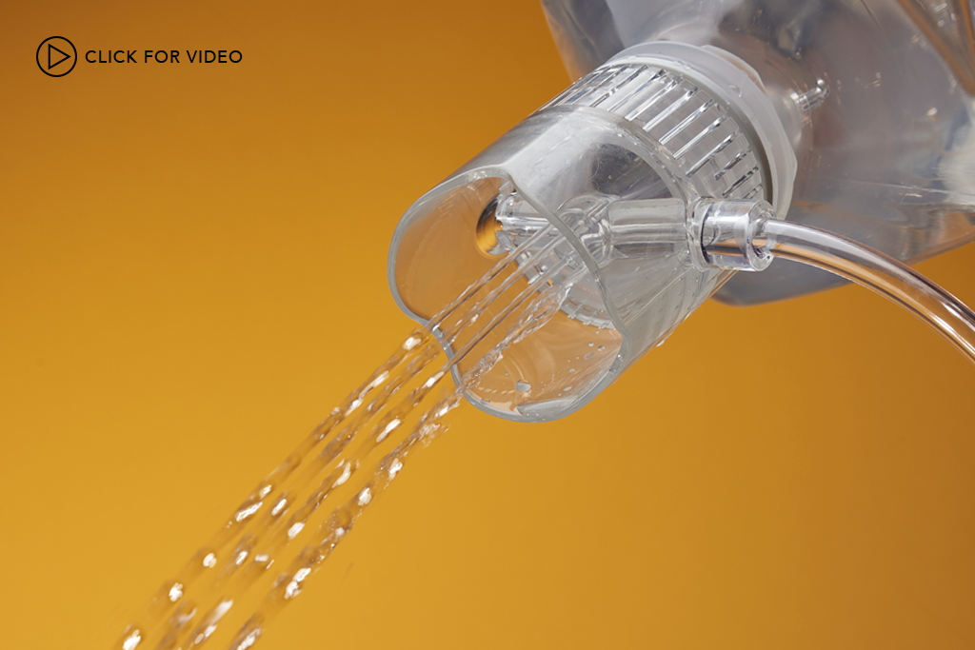
After anesthetizing the wound with lidocaine, I set up the IRIG-8 on a 1L bottle of saline and set the oxygen to 3.5L/min. I irrigated this entire liter of saline, filled the bottle with tap water, and irrigated again. Since this was one of the first times I officially used IRIG-8 on a real patient, I was impressed for several reasons. First, it allowed my left hand to be free to open, explore, and expose the wound. I was able to start and stop several times to reexamine the wound and make sure that the dirt and debris were being removed. Second, its clear plastic design allowed me to see the wound while irrigating, so that I knew that the five water streams were directed exactly where needed. Lastly, I felt very confident that the wound was effectively irrigated knowing that I placed a large amount of water on it, two liters to be exact. I could even document that the wound was irrigated at ten PSI. The whole irrigation process took less than 2 minutes.
Looking back at “standard” wound irrigation technique with a syringe and splash guard, it is easy to see that the “standard” would have taken significantly longer. Multiple refills of a 20 or 30cc syringe is not only time consuming, it leads to frustration and likely under-irrigation due to the time it takes to perform. I irrigated the wound more than I would have with the traditional syringe and splash guard push-and-pull method. When your ED is backed up with patients in the waiting room, and you’re dealing with multiple patients simultaneously, anything that saves time is valuable.
This particular patient also illustrates the importance of quality instruments in the ED setting. My hospital just recently switched to Centurion’s instrument kits. I cannot emphasize enough how these instruments impacted this patient's care. Numerous sutures, using 6.0 Prolene, tying numerous knots-knowing that the thread is not going to snag on the needle driver. Also, having complete confidence in my instruments allows me to focus on the repair and not having to open up multiple cheap kits because of instrument failure or having to get an expensive “plastics tray” from sterile processing. Everything I need is readily available in a single Centurion laceration kit.
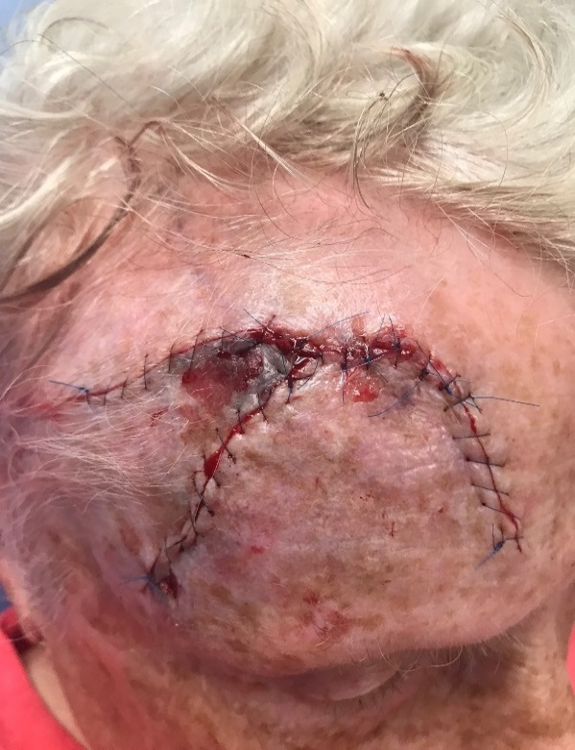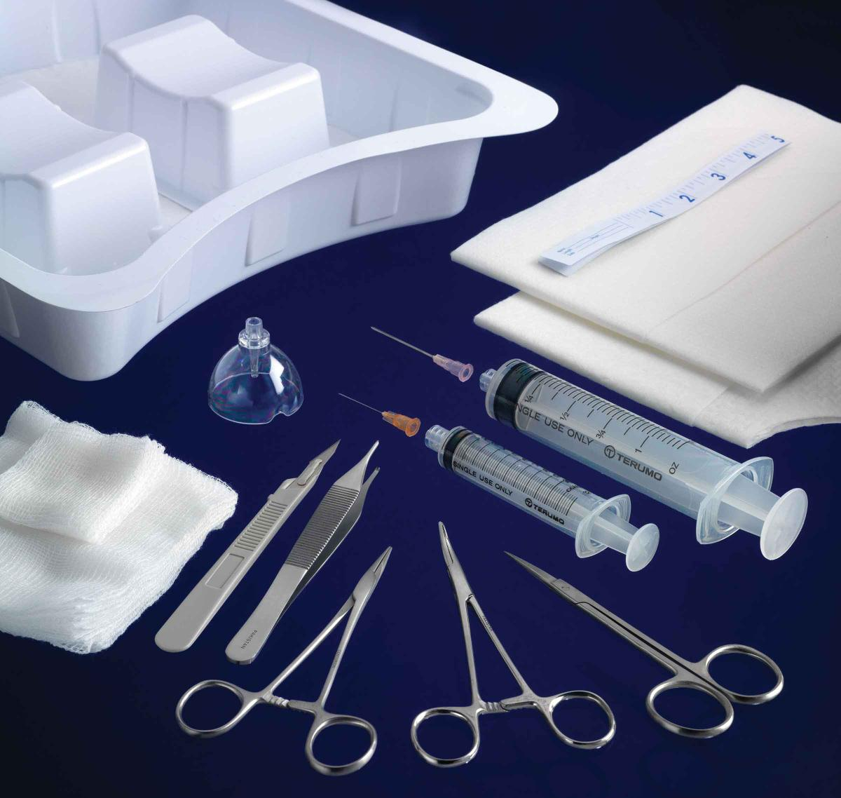

FREQUENTLY ASKED QUESTIONS:
- What type of wounds would benefit most from using IRIG-8?
All wounds could be considered, but personally, for lacerations 4 – 5 cm and greater, this is something I would strongly consider using. Current recommendations are to use 50 – 100 cc of water per centimeter of wound. It takes a fair amount of time to irrigate 500 cc of saline using a small syringe. For contaminated wounds, it allows us to put more irrigant into the wound and really clean it well, hopefully decreasing the possibility of retained foreign bodies, and of course, the risk of infection.
- What role do you see IRIG-8 playing in the trauma setting?
In larger centers with trauma teams, there’s a lot going on simultaneously. Different people are managing the patient, starting IVs, getting X-rays, assessing the patient. During the process, a large laceration may get ignored. IRIG-8 will allow someone to assess the wound, quickly irrigate it, and apply a compressive dressing or possibly staple it. Let's say you have an open ankle fracture. While the trauma team is resuscitating the patient, the orthopedic resident could use IRIG-8 with a liter or two of saline, reduce the fracture, splint it, and deal with it definitively in the OR later. It would be a huge time savings and may provide a better chance at reducing infection risk.
- Do you think IRIG-8 would allow more personnel to irrigate ED wounds?
Currently, as wound irrigation varies from user to user, I feel it's something that I need to do myself as a doctor. I've seen nurses, and other physicians for that matter, barely dribbling water out of the syringe to irrigate a wound. There’s no way to standardize it with traditional techniques. However, with IRIG-8, I know how much pressure will be generated once the tubing is attached to oxygen. After minimal training with IRIG-8, I’d feel comfortable having a nurse or trusted tech irrigate the wound for me ahead of time. Also, with a bad case of road rash, it would be a huge help for the nurse to go ahead and use IRIG-8 to get rid of the dirt and debris. I think this is an excellent opportunity for time savings.
- Can you use IRIG-8 on areas of the body not related to wounds?
The intended use for IRIG-8 is for irrigating wounds. Irrigating another part of the body, the eye for example, would be off label.

